Exercises: Django Models Relations
Submit your solutions to the SoftUni Judge system.
Ask your questions here: https://www.slido.com by entering the course code #python-db

Library
Write a Django model called "Author" with the provided field:
- name - character field, consisting of a maximum of 40 characters.
Write a second Django model called "Book" with the provided fields:
- title - character field, consisting of a maximum of 40 characters.
- price - decimal field, with a maximum of 5 digits and 2 decimal places.
- author - many-to-one relation to the "Author" class. If an author is deleted, you should automatically delete all the related books.

Functions inside the caller.py file
show_all_authors_with_their_books() returns a string with authors and their books, separated by comma and space - ", ", ordered by the id of the author (ascending) as follows:
- "{author_name_1} has written - {book_1, book_2, book_N}!
…
{author_name_N} has written - {book_1, book_2, book_N}!"
Note: If an author does not have any books, continue to the next one.
delete_all_authors_without_books() deletes all authors that do not have any book related to them.

Examples
Test code - caller.py
# Create authors
author1 = Author.objects.create(name="J.K. Rowling")
author2 = Author.objects.create(name="George Orwell")
author3 = Author.objects.create(name="Harper Lee")
author4 = Author.objects.create(name="Mark Twain")
# Create books associated with the authors
book1 = Book.objects.create(
title="Harry Potter and the Philosopher's Stone",
price=19.99,
author=author1
)
book2 = Book.objects.create(
title="1984",
price=14.99,
author=author2
)
book3 = Book.objects.create(
title="To Kill a Mockingbird",
price=12.99,
author=author3
)
# Display authors and their books
authors_with_books = show_all_authors_with_their_books()
print(authors_with_books)
# Delete authors without books
delete_all_authors_without_books()
print(Author.objects.count())
Output
J.K. Rowling has written - Harry Potter and the Philosopher's Stone!
George Orwell has written - 1984!
Harper Lee has written - To Kill a Mockingbird!
3

Music App
Write a Django model called "Song" with the provided fields:
- title - character field, consisting of a maximum of 100 characters, unique.
Write a second Django model called "Artist" with the provided fields:
- name - character field, consisting of a maximum of 100 characters, unique.
- songs - many-to-many relation to the "Song" class. The field has a related name set to "artists".

Functions inside the caller.py file
add_song_to_artist(artist_name: str, song_title: str) gets the artist object by the artist's name and the song object by the song's title, and adds the song object to the artist's songs collection.
get_songs_by_artist(artist_name: str) returns all the song objects from the songs collection in a queryset, ordered by song id (descending) for the given artist.
remove_song_from_artist(artist_name: str, song_title: str) gets the artist object by the artist's name and the song object by the song's title, and removes the song object from the artist's songs collection.

Examples
Test code - caller.py
# Create artists
artist1 = Artist.objects.create(name="Daniel Di Angelo")
artist2 = Artist.objects.create(name="Indila")
# Create songs
song1 = Song.objects.create(title="Lose Face")
song2 = Song.objects.create(title="Tourner Dans Le Vide")
song3 = Song.objects.create(title="Loyalty")
# Add a song to an artist
add_song_to_artist("Daniel Di Angelo", "Lose Face")
add_song_to_artist("Daniel Di Angelo", "Loyalty")
add_song_to_artist("Indila", "Tourner Dans Le Vide")
# Get all songs by a specific artist
songs = get_songs_by_artist("Daniel Di Angelo")
for song in songs:
print(f"Daniel Di Angelo: {song.title}")
# Get all songs by a specific artist
songs = get_songs_by_artist("Indila")
for song in songs:
print(f"Indila: {song.title}")
# Remove a song from an artist
remove_song_from_artist("Daniel Di Angelo", "Lose Face")
# Check if the song is removed
songs = get_songs_by_artist("Daniel Di Angelo")
for song in songs:
print(f"Songs by Daniel Di Angelo after removal: {song.title}")
Output
Daniel Di Angelo: Loyalty
Daniel Di Angelo: Lose Face
Indila: Tourner Dans Le Vide
Songs by Daniel Di Angelo after removal: Loyalty

Shop
Write a Django model called "Product" with the provided field:
- name - character field, consisting of a maximum of 100 characters, unique.
Write a second Django model called "Review" with the provided fields:
- description - text field, consisting of a maximum of 200 characters.
- rating – positive small integer field.
- product - many-to-one relation to the "Product" class. If a product is deleted, you should automatically delete all the related reviews. The field has a related name set to "reviews".

Functions inside the caller.py file
calculate_average_rating_for_product_by_name(product_name: str) returns the calculated average rating for a given product by its name.
get_reviews_with_high_ratings(threshold: int) returns all reviews with greater than or equal ratings to the threshold.
get_products_with_no_reviews() returns all products that do NOT have any related reviews, ordered by product name (descending).
delete_products_without_reviews() deletes all the products that do not have any related reviews.

Examples
Test code - caller.py
# Create some products
product1 = Product.objects.create(name="Laptop")
product2 = Product.objects.create(name="Smartphone")
product3 = Product.objects.create(name="Headphones")
product4 = Product.objects.create(name="PlayStation 5")
# Create some reviews for products
review1 = Review.objects.create(description="Great laptop!", rating=5, product=product1)
review2 = Review.objects.create(description="The laptop is slow!", rating=2, product=product1)
review3 = Review.objects.create(description="Awesome smartphone!", rating=5, product=product2)
# Run the function to get products without reviews
products_without_reviews = get_products_with_no_reviews()
print(f"Products without reviews: {', '.join([p.name for p in products_without_reviews])}")
# Run the function to delete products without reviews
delete_products_without_reviews()
print(f"Products left: {Product.objects.count()}")
# Calculate and print the average rating
print(calculate_average_rating_for_product_by_name("Laptop"))
Output
Products without reviews: PlayStation 5, Headphones
Products left: 2
3.5

License
Write a Django model called "Driver" with the provided fields:
- first_name - character field, consisting of a maximum of 50 characters.
- last_name - character field, consisting of a maximum of 50 characters.
Write a second Django model called "DrivingLicense" with the provided fields:
- license_number - character field, consisting of a maximum of 10 characters, unique.
- issue_date - date field.
- driver - one-to-one relation to the "Driver" class. If a driver is deleted, you should automatically delete the related license. The field has a related name set to "license".

Functions inside the caller.py file
calculate_licenses_expiration_dates() calculates the expiration date for all licenses. The expiration date is 365 days after the issue date. Return the license number and the expiration date as a string, ordered by license number (descending) as follows:
- "License with number: {license_number_1} expires on {expiration_date_1}!
…
License with number: {license_number_N} expires on {expiration_date_N}!"
get_drivers_with_expired_licenses(due_date: date) returns all drivers that have expired licenses. A license counts as expired when the expiration date is one or more days after the due date.

Examples
Test code - caller.py
# Create drivers
driver1 = Driver.objects.create(first_name="Tanya", last_name="Petrova")
driver2 = Driver.objects.create(first_name="Ivan", last_name="Yordanov")

# Create licenses associated with drivers
license1 = DrivingLicense.objects.create(license_number="123", issue_date=date(2022, 10, 6), driver=driver1)
license2 = DrivingLicense.objects.create(license_number="456", issue_date=date(2022, 1, 1), driver=driver2)
# Calculate licenses expiration dates
expiration_dates = calculate_licenses_expiration_dates()
print(expiration_dates)
# Get drivers with expired licenses
drivers_with_expired_licenses = get_drivers_with_expired_licenses(date(2023, 1, 1))
for driver in drivers_with_expired_licenses:
print(f"{driver.first_name} {driver.last_name} has to renew their driving license!")
Output
License with number: 456 expires on 2023-01-01!
License with number: 123 expires on 2023-10-06!
Tanya Petrova has to renew their driving license!

Car Registration
Write a Django model called "Owner" with the provided information:
- name - character field, consisting of a maximum of 50 characters.
Write a second Django model called "Car" with the provided information:
- model - character field, consisting of a maximum of 50 characters.
- year - positive integer field.
- owner - many-to-one relation to the "Owner" class. If an owner is deleted, you should automatically delete all the related cars. The field is optional and has a related name set to "cars".
Write a third Django model called "Registration" with the provided information:
- registration_number - character field, consisting of a maximum of 10 characters, unique.
- registration_date - date field, optional.
- car - one-to-one relation to the "Car" class. If a car is deleted, you should automatically delete the related registration. The field is optional and has a related name set to "registration".

Functions inside the caller.py file
register_car_by_owner(owner: Owner) that register cars with the given owner object:
- First, get the first registration that is not related to any car. After that get the first car without registration.
- Then, you should set the new registration to the car object. The registration date should be set to the current day of the registration (today) to the registration object. Do not forget to save all the changes in the database.
- Lastly, return the car model, the owner's name, and the registration number as a string as follows:
"Successfully registered {car_model} to {owner_name} with registration number {registration_number}."

Examples
Test code - caller.py
# Create owners
owner1 = Owner.objects.create(name='Ivelin Milchev')
owner2 = Owner.objects.create(name='Alice Smith')
# Create cars
car1 = Car.objects.create(model='Citroen C5', year=2004)
car2 = Car.objects.create(model='Honda Civic', year=2021)
# Create instances of the Registration model for the cars
registration1 = Registration.objects.create(registration_number='TX0044XA')
registration2 = Registration.objects.create(registration_number='XYZ789')
print(register_car_by_owner(owner1))
Output
Successfully registered Citroen C5 to Ivelin Milchev with registration number TX0044XA.

Constraints
- The owner will always have at least one car.

*Car Admin Setup [Solve with AI]
You are going to work with the model "Car" from exercise 5. In the "admin.py" file inside the "main_app" create a super user and create and register the "CarAdmin" model and use:
- list_display - including the fields: model, year, owner, and car_details.

Methods inside the CarAdmin model
car_details(obj: object) is a static method and returns information about the owner and the registration number of all cars as follows:
- "Owner: {owner_name}, Registration: {registration_number}"
- If the car has no owner, the function should return "No owner".
- If the car has no registration, the function should return "No registration number".
Also, include a user-friendly short description for that method named "Car Details".

Hint
car_details(obj): This is a custom method that takes an instance of the Car model (obj) and returns a string based on whether the car has an owner and a registration. It constructs a string that includes the owner's name and registration number or "No owner" and "No registration number" if the respective fields are missing.
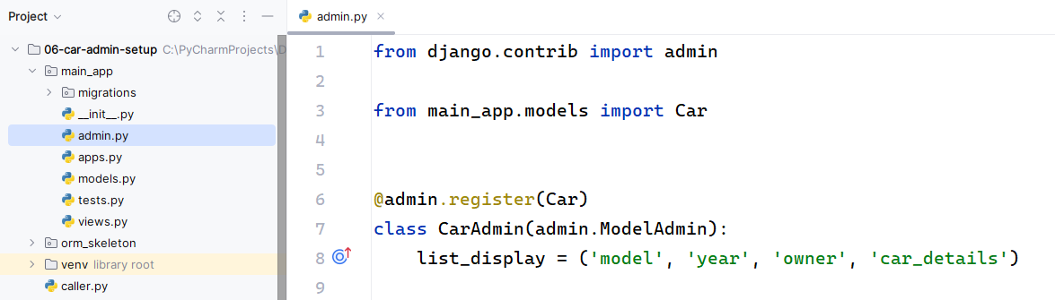
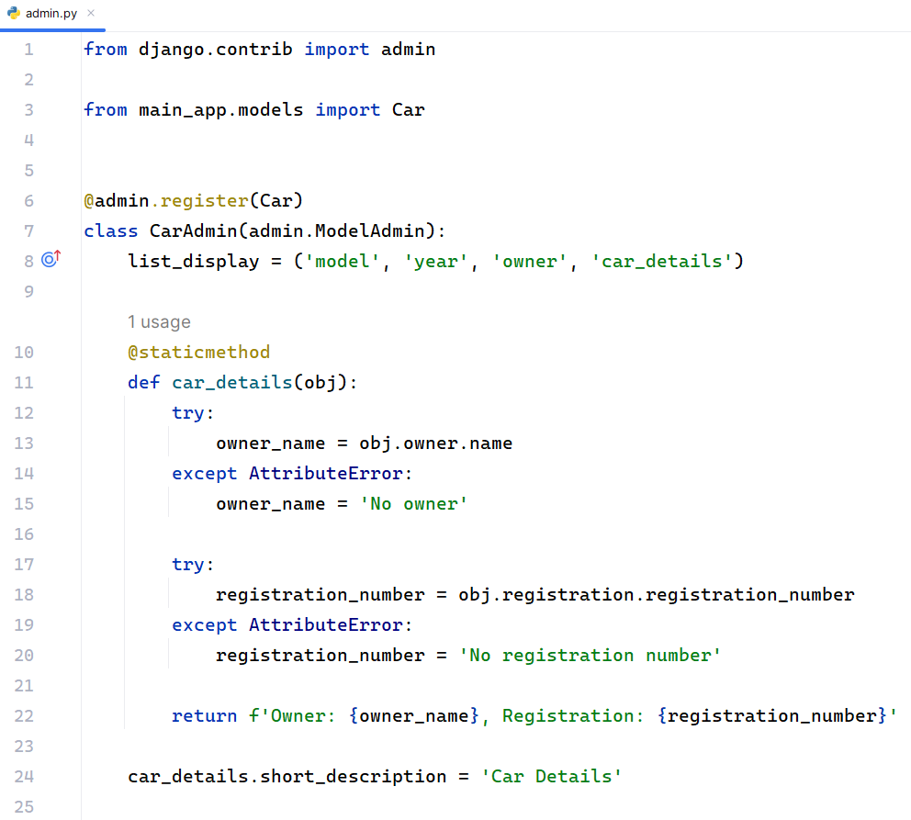
"car_details.short_description": This sets a custom column header for the "car_details()" method in the admin list view. Once you're logged in, navigate to the list view of the "Car" model. You should see a custom column labeled "Car Details" that displays the information about the owner and registration number for each car, as specified in the "car_details()" method.
